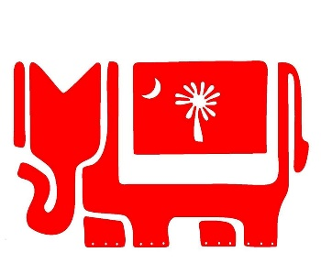
Check /Cash/Date

Upstate Republican Women
Welcome you to JOIN!
2021 Membership Form
Name ________________________________ Address___________________________

City/State/Zip/ _______________________ Email ______________________________

Home Phone ________________Cell __________________Birthday ________ (no year)

Regular Member $30. ___ Renewal or New / Sponsored by _____________________

Associate Member $25 ____________Primary Club if not URW ___________________

Any Donations or Sponsorships ____________________________________________
If you would like to make a donation on Sponsor a Luncheon or Reception, please add amount.

Occupation ___________________ Employer _____________________________

SC Senate Rep___________________ House Rep _____________________

US House: Circle - Jeff Duncan or William Timmons

Committees and Interests
Please let us know if you are interested in any of the following Committees. We welcome you to get involved where you feel comfortable.
If there is already a chair, we welcome you to participate in the committee. All Committees need help!

Please Circle any that interests you.

• Membership • Caring for American/Veterans

• National Awards • Chaplain and Hospitality

• Media/Public Relations • Fund raising/Events

• Legislation, Parliamentarian, By Laws • Campaign/Volunteer Hours

• In Club Communications and Newsletter

Membership forms can be mailed to: URW – PO Box 26342 – Greenville, SC - 29616

